Title: Evidence on transmission mechanisms
Subject: MTP

0. Structural vs Reduced form Evidence  1. How monetary policy affects the real economy (in Practice!)  A. LR  Reduced Form Estimates  B. SR  a. Early Keynesian theories based on structural model evidence  b. Early monetarist evidence mainly based on reduced-form evidence (pro ST effects) | Structural model evidence: Examines whether one variable affects another by using a model that tries to explains the channels through which the variables interact.  Pro: Possible to gather more evidence on the transmission dynamics → more confidence on the direction of causation  Con: Only as good as the model it is based on  Reduced-form evidence: Examines whether one variable has an effect on another variable simply by looking directly at the relationship between the two variables (ex. empirical study on correlation)  Pro: No restrictions imposed on the way monetary policy affects the economy, light on assumptions  Con: Correlation does not imply causation (reverse causation, outside driving factor)  “Does monetary policy matter?” inherently hard to answer.  Regression GDP = β₀ + β₁i₁ + ν is biased due to simultaneity: i affects GDP but at the same time GDP affects i (MP is endogenous to economic conditions = The business cycle drives monetary policy!). Extreme case: if monetary policymakers use policy to successfully counteract other detrimental forces affecting GDP, one would find monetary policy variables moving and output not changing.  Methodology: Correlation analysis of inflation-MoneyGrowthRate, RealGDP-MoneyGrowthRate, and inflation-RealGDP  Take 110 countries, compute average rates on 30 yrs. Two subsets: OECD countries and Latin America  Results  i. Inflation-MoneyGrowthRate are highly correlated for all three money definitions, also in both subsamples (almost 1).  ii. RealGDP-MoneyGrowthRate are not correlated, except for the OECD subsample (positive strong correlation: 0.7 wrt M0).  However, correlation illustrates direction and strength of a relation, but not magnitude! If we run a linear regression Slope is just 0.1!(1% money growth creates 0.1% output growth)  iii. inflation-RealGDP are essentially uncorrelated  They had in their hands a model where the Investment transmission mechanism had bee defined. They thought: i ↓ → I ↑ → Y ↑  They saw that:  i. Low interest rates during the Great Depression indicated expansionary monetary  ii. Empirical studies found no linkage between movement in nominal interest rates and investment spending  iii. Surveys of business people confirmed that investment in physical capital was not based on market interest rates  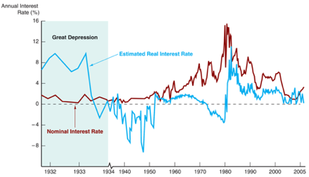  ---> Concluded that money is NOT important to economic fluctuations  BUT Friedman and Schwartz: MP was actually contractionary during the Great Depression:  i. Many different interest rates, what matters for spending is not the overnight interest rate, but other interest rates (loans, mortgages). There was huge spread.  ii. During deflation, low nominal interest rates do not necessarily indicate expansionary policy  iii. Weak link between nominal interest rates and investment spending does not rule out a strong link between real interest rates and investment spending  Three possible reduced-form approaches:  i. Timing evidence/ Statistical evidence  Timing evidence: looks at whether movements in one variable typically occur after another  Friedman and Schwartz found that in every business cycle oney growth rate always declined before output did, with a lead time that could vary from a few months to more than two years --> Concluded that money growth causes business cycle fluctuations but its effects operate with long lags  Problems: omitted variable bias + reverse causation (Christmas postal cards arrive before Christmas but they do not cause Christmas to happen)  ii. Historical/narrative evidence (Romer and Romer )  Read the historical minutes of Federal Reserve policymaking meetings to identify times when monetary policy was modified for reasons unrelated to current economic activity. Looks at specific economic episodes that appear to be exogenous events (CB decided to act even if economy was at natural level). Friedman and Schwartz (1963) document several episodes. Example: Increase in reserve requirements in 1936-1937 that led to a sharp decline in money supply. Increase implemented because the Fed wanted to improve its control of monetary policy, NOT implemented in response to economic conditions = Rule out reverse causation.  Historical evidence is strong evidence that monetary policy has an impact on output. Romer and Romer contractionary MP shock Results:  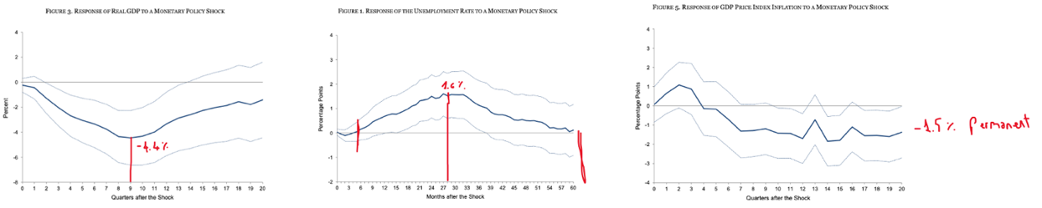  iii. Vector Auto Regressions (VARs)  Statistical process to isolate exogenous component of MTP-Output relationhsip  